DOCUMENTATION

ASSIGNMENT 1

STUDENT NAME: Marin Andreea
GROUP: 30421

CONTENTS

1. Objectives 3
2. Dimensions of the problem 4
3. Projection 7
4. Implementation 12
5. Results 15
6. Conclusions 16
7. Bibliography 17

Objectives

- Main objective
Design and implement a polynomial calculator with a dedicated graphical interface through which the user can insert polynomials, select the mathematical operation to be performed and view the result.
- Sub-objectives

Analyze the problem and identify requirements | The problem is analyzed and both functional and non-functional requirements are being identified.  (More details: Chapter 2)
Design the polynomial calculator | Divide the problem into packages by using a Model View Controller Architectural Pattern  (More details: Chapter 3)
Implement the polynomial calculator | Implement methods for addition, subtraction, multiplication, differentiation and integration of polynomials.  (More details: Chapter 4)
Test the polynomial calculator | Create the test class and implement methods to test all the five operations performed on polynomials.  (More details: Chapter 5)

Dimensions of the problem

  - . Analyzing the problem
A polynomial is an expression that can be built from constants and symbols called indeterminates or variables by means of addition, multiplication and exponentiation to a non-negative integer power. The constants are generally numbers, but may be any expression that do not involve the indeterminates, and represent mathematical objects that can be added and multiplied.
A polynomial in a single indeterminate x can always be written (or rewritten) in the form
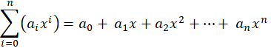
where are constants and is the indeterminate. The word "indeterminate" means that represents no particular value, although any value may be substituted for it.
The polynomial consists of a list of certain terms, also called monomials, for example 7x^2 is a monomial. The coefficient is 7, the indeterminate is and the degree is 2. Forming a sum of several terms produces a polynomial, like the following one: 6x^3 + 3x^2 - 5, which has three terms with different exponents: the first is degree three, the second is degree two, and the third is degree zero.

  - . Modelling the problem

At this point both functional and non-functional requirements can be established:
Functional requirements | Non-functional requirements
The calculator should allow users to insert polynomials | The polynomial calculator should be intuitive and easy to use by the user
It should allow users to select the mathematical operation
It should be able to add two polynomials
It should be able to subtract two polynomials
It should be able to multiply polynomials
It should be able to differentiate two polynomials
It should be able to integrate two polynomials

The user will be able to see the functionality of the polynomial calculator by introducing two polynomials, in the corresponding text fields, and selecting the operation to be performed, in the graphical interface. The operations that can be performed by the calculator are the following:
- Addition of two polynomials
- Subtraction of two polynomials
- Multiplication of two polynomials
- Differentiation of two polynomials
- Integration of two polynomials

The result of the chosen operation will be displayed in the text field associated to the label “Result”.

  - . Scenario and use cases

    - Scenario
A normal functionality of the program involves the insertion of the first polynomial in its corresponding text field, followed by the insertion of the second polynomial in it corresponding text field. Both polynomials must be introduced by respecting the following format: c1^p1+c2^p2...., (where c1,c2,...,cn are doubles and p1,p2,...,pn are integers; Example: 3.0x^3+7.0x^2-1.0x^1-9.0x^0). The next set consists of choosing the desired operation by clicking on the corresponding button and, if the polynomials were correctly introduce, the result will appear on the screen. If one of the polynomials have the coefficient 0, then the error message “Bad input!” will be displayed.

    - Use cases
A use case is a methodology used in system analysis to identify, clarify and organize system requirements. The use case is made up of a set of possible sequences of interactions between systems and users in a particular environment and related to a particular goal. A complete use case will include one main or basic flow and various alternate flows. The alternate flow, also known as an extending use case, describes normal variations to the basic flow as well as unusual situations.
The use cases are strongly connected with the steps that the user has to do in order to be able to see the result of the chosen operation.
Example of use case for the multiplication operation:
Use case: multiply polynomials
Primary Actor: the user
Main Success Scenario:
- The user introduces two polynomials in the graphical user interface, by respecting the required format
- The user clicks on the multiplication operation button represented by the multiplication symbol “*”
- The polynomial calculator performs the multiplication of the two polynomials and displays the result
Alternative Sequence: Incorrect polynomials
- The user does not follow the required format for introducing a polynomial (e.g. introducing a polynomial in which a monomial has coefficient 0)
- The scenario returns to step 1

- Projection
For this project I have used a MVC (Model-View-Controller) Architecture.
Model–view–controller (MVC) is a software design pattern commonly used for developing user interfaces that divide the related program logic into three interconnected elements. This is done to separate internal representations of information from the ways information is presented to and accepted from the user.
Traditionally used for desktop graphical user interfaces (GUIs), this pattern became popular for designing web applications. Popular programming languages have MVC frameworks that facilitate implementation of the pattern.

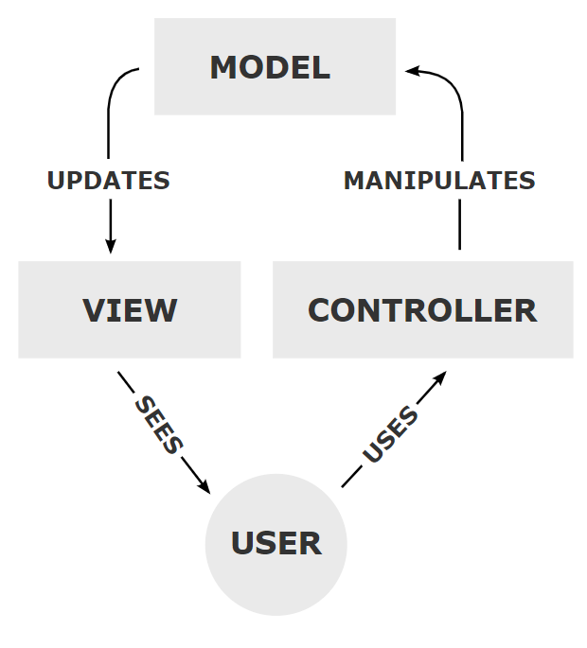
Model
The central component of the pattern. It is the application's dynamic data structure, independent of the user interface. It directly manages the data, logic and rules of the application.
View
Any representation of information such as a chart, diagram or table. Multiple views of the same information are possible, such as a bar chart for management and a tabular view for accountants.
Controller
Accepts input and converts it to commands for the model or view.
In addition to dividing the application into these components, the model–view–controller design defines the interactions between them.
- The model is responsible for managing the data of the application. It receives user input from the controller.
- The view renders presentation of the model in a particular format.
- The controller responds to the user input and performs interactions on the data model objects. The controller receives the input, optionally validates it and then passes the input to the model.
As with other software patterns, MVC expresses the "core of the solution" to a problem while allowing it to be adapted for each system. Particular MVC designs can vary significantly from the traditional description here.

  - . Diagrams

    - Use case Diagram

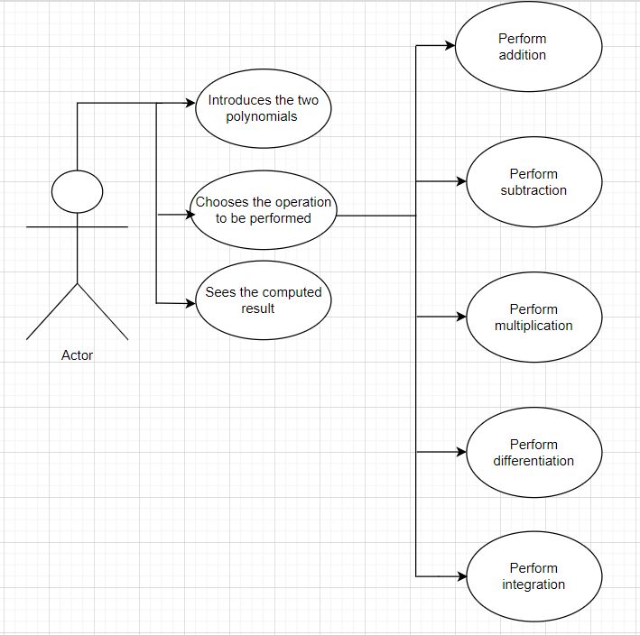

The actor interacts with the application and can perform five operations on the two introduced polynomials.

    - UML Diagrams

- Class Diagram

A class diagram is a diagram used in designing and modeling software to describe classes and their relationships. Class diagrams enable us to model software in a high level of abstraction and without having to look at the source code.

Classes in a class diagram correspond with classes in the source code. The diagram shows the names and attributes of the classes, connections between the classes, and also the methods of the classes.

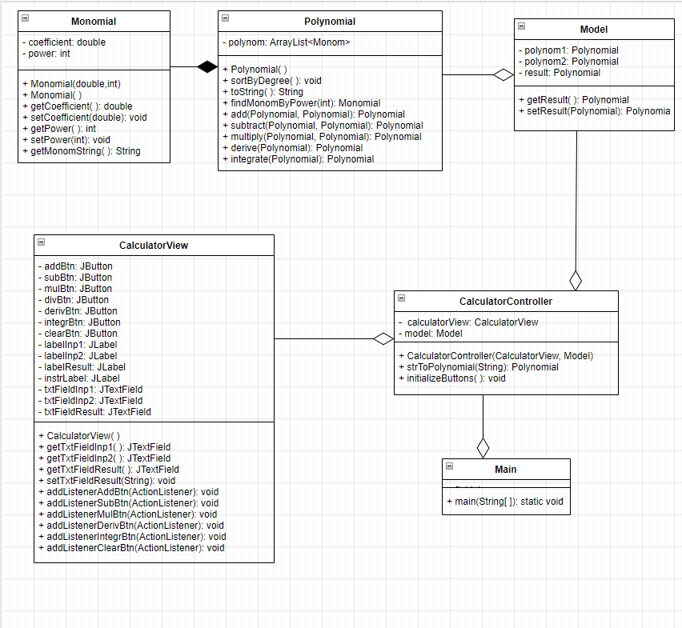

  - Data structures used

The data types that I used for this project are primitive data types (integer and double) and ArrayList.
I have decided to use ArrayList instead of array because it is more flexible than a plain native array. Working with ArrayLists gave me the possibility of increasing its size dynamically as it has variable length. It also provides constant time for search operation which I needed in order to find the monomial with a specific power in a polynomial.

  - Interface

I tried to design my interface in a friendly and easy to use way by giving suggestive names to the buttons and labeles. I also added a note in which I remaind the user to enter the input following the correct format.
The user can introduce one or two polynomials, depending on the desired operation to be performed. Every introduced polynomial is composed of one or more terms. Each term must respect the format[sign][coefficient][x^][power], except the first term which, if it has a positive coefficient, can be introduced without introducing the sign +. Even coefficients equal to 1 and powers equal to 0 or 1 must be specified in the input for a correct functionality of the application.

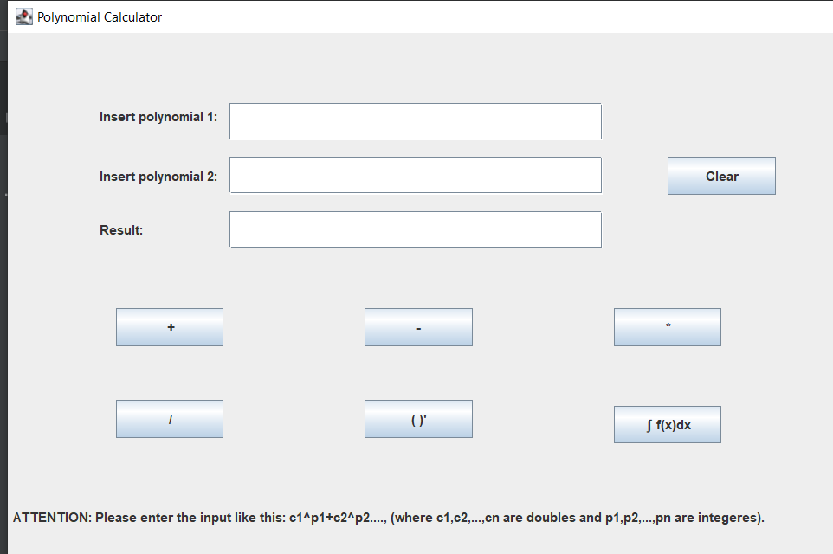

  - Algorithms

- Addition

The sum of two polynomials is obtained by adding together the coefficients sharing the same powers of variables.
- Subtraction
The sum of two polynomials is obtained by adding together the coefficients sharing the same powers of variables.
- Multiplication
The product of two polynomials is obtained by multiplying term by term and combining the results.
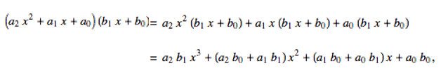
- Differentiation
Drop the ordered pair that has a zero exponent. For every other ordered pair, multiply the coefficient by the exponent, and then subtract one from the exponent.

- Integration
The algorithm multiplies the coefficient with the exponent and divides it with the exponent incremented by one.

Implementation

Because I used the Model-View-Controller Architecture, my project is divided in four parts:
- The Model
It directly manages the data, logic and rules of the application and contains three classes: Monomial, Polynomial and Model.

- Class Main
The class Main has the role of launching the application.
CalculatorView calculatorView = new CalculatorView();
Model model = new Model();
CalculatorController c = new CalculatorController(calculatorView,model);
calculatorView.setVisible(true);

- Class Monomial
A polynomial is composed by one or more terms called monomials.
This class has two instance variables: “coefficient” of type double and “power” of type int.
Constructors:
- public Monomial(double coefficient, int power): initializes the monomials with the coefficient and power from the parenthesis.
- public Monomial(): initializes the monomials by setting to 0 the coefficient and power (default constructor)
Getters and setters:
- public double getCoefficient(): returns the coefficient of the monomial
- public void setCoefficient(double coefficient): sets the coefficient of the monomial
- public int getPower(): returns the power of the monomial
- public void setPower(int power): sets the power of the monomial

Methods:
- public String getMonomString(): returns the monomial as a string

- Class Polynomial
Class Polynomial has only one instance variable: an ArrayList<Monomial> that is used to store the monomials of a polynomial.
Constructor:
- public Polynomial(): default constructor used to initialize the polynomial with 0
Getter:
- public ArrayList<Monomial> getPolynom(): returns the polynomial
Methods:
- public void sortByDegree(): sorts the polynomial in increasing way based on the powers of the monomials that the polynomial contains, by overriding the public in compare method
- public Monomial findMonomByPower(int degree): find the monomial with the specified power and returns it
- public String toString(): overrides the method public String toString() and returns the polynomial as a string by using the getMonomString() method from the Monomial class
- public static Polynomial add(Polynomial polynom1, Polynomial polynom2): computes the sum of the two polynomials and returns it
- public static Polynomial subtract(Polynomial polynom1, Polynomial polynom2): computes the difference of the two polynomials and returns it
- public static Polynomial multiply(Polynomial polynom1, Polynomial polynom2): computes the multiplication of the two polynomials and returns it
- public static Polynomial derive(Polynomial polynom): computes the differentiation of the polynomial and returns it
- public static Polynomial integrate(Polynomial polynom): computes the integration of the polynomial and returns it

- Class Model
Constructor:
- public Model(): initializes the polynomials used for operations, as well as, the result of the chosen operation
Getters and setters:
- public Polynomial getResult(): returns the value of the result
- public void setResult(Polynomial result): sets the value of the result

- The View
This package contains the graphical user interface. It consists of only one class.
- Class CalculatorView
This class extends JFrame. JFrame is a top-level container that provides a window on the screen. A frame is actually a base window on which other components rely, namely the menu bar, panels, labels, text fields, buttons, etc.
The default constructor initializes the frame and sets up the size, visibility, layout and position of the labels, buttons and text fields declared as well as add the elements. It sets: the title of the application “Polynomial Calculator” which will be displayed in the top left corner of the window; the size of the window and the EXIT_ON_CLOSE option.
The class also contains getters and setters for the text fields declared and ActionListener methods for all the buttons in the graphical user interface(+,-,*,()’, ∫ f(x)dx, Clear). All these action listeners are implemented in the Control package
- The Controller
This package contains the linking between the model and the view. It controls data flow in the model and updates the view every time data changes. It contains only one class.
- Class CalculatorController
This class contains two private variables, one of type CalculatorView and the other one of type Model. It contains a method called “strToPolynomial” which finds a pattern in the polynomial read as a string and extracts the coefficient and the power of each monomial and adds it to the polynomial to be returned. This method is used to construct the polynomials from the strings that the user introduces in the text fields. The action listeners for all the six buttons are implemented in this class. The action listeners for the buttons representing operations first get the text of the inputs from the corresponding text fields, performs the specific operation and sets the result. If an exception is caught in the text field of the result an error message will be displayed: “Bad input!”. The clear button has also an action listener which simply sets to null the text fields for polynomial 1, polynomial 2 and result.

- The Class Main
The class Main has the role of launching the application.
CalculatorView calculatorView = new CalculatorView();
Model model = new Model();
CalculatorController c = new CalculatorController(calculatorView,model);
calculatorView.setVisible(true);

Results
When it comes to testing, I used JUnit. Each of the five operations: addition, subtraction, multiplication, differentiation and integration have separate testing methods which verify if the operation methods have been correctly implemented. All testing methods are placed in a class called “OperationTest” placed in the package Model of the testing directory “java”. The class extends TestCase. For each test, I declared the polynomial or polynomials used and the expected polynomial. After performing the operation to be tested, by using “assertEqals” I verify it the expected result is equal to the actual result of the operation:

assertEquals(expectedP.toString(),diff.toString())

Each method of the class OperationTest should be preceded by @Test.

Operation to be  tested | Input Data | Expected Output | Actual result | Pass/Fail the test
Addition | 3.0x^2+2.0x^1-1.0x^0;  4.0x^3-3.0x^1+2.0x^0 | 4.0x^3+3.0x^2-1.0x^1+1.0 | 4.0x^3+3.0x^2-1.0x^1+1.0 | Pass
Subtraction | 3.0x^2+2.0x^1-1.0x^0;  4.0x^3-3.0x^1+2.0x^0 | -4.0x^3+3.0x^2+5.0x^1-3.0 | -4.0x^3+3.0x^2+  5.0x^1-3.0 | Pass
Multiplication | 3.0x^2+2.0x^1;  4.0x^3+2.0x^0 | 12.0x^5+8.0x^4+6.0x^2+4.0x^1 | 12.0x^5+8.0x^4+  6.0x^2+4.0x^1 | Pass
Differentiation | 4.0x^3+3.0x^2+2.0x^1-1.0x^0 | 12.0x^2+6.0x^1+2.0x^0+0.0 | 12.0x^2+6.0x^1+  2.0x^0+0.0 | Pass
Integration | 4.0x^3+3.0x^2+2.0x^1-1.0x^0 | 1.0x^4+1.0x^3+1.0x^2-1.0x^1 | 1.0x^4+1.0x^3+  1.0x^2-1.0x^1 | Pass

Conclusions

In conclusion, this project helped me remember and fix the Object Oriented Programming concepts learned in the first semester.
One interesting thing that I learned from doing this project was working with regular expression and pattern matching as I haven’t worked with them before. They were useful for constructing the polynomials out of the strings taken from the text fields of the two polynomials.
Another thing that I learned from the project was how important time management is.

When it comes to further improvements, my application can be improved by adding new functionalities, such as:
- Compute the division between two polynomials
- Find the roots of the polynomials
- Calculate the polynomials for a given value x
- Plot the graphic of the polynomials

Bibliography

- Programming Techniques – Lecture Slides of prof. Cristina Bianca POP
- Object-Oriented Programming - Lecture Slides of prof. Marius JOLDOS
- https://www.draw.io/ -for diagrams
- www.stackoverflow.com
- https://en.wikipedia.org/wiki/Model%E2%80%93view%E2%80%93controller – for the MVC Architecture
- https://stackoverflow.com/questions/36490757/regex-for-polynomial-expression - for implementing the function with pattern matching

